What’s the purpose of feelings?
Why do humans have emotions?
Humans are a social species. We are not solitary animals, designed instead to live in groups, usually multi-family groups. The general consensus is that human emotions exist as a way to help us communicate with other members of our group. Emotions, in fact, help us communicate without saying a world, and emotions are a universal language. All across the world, people show basic emotions in the same way. The five basic emotions include joy, sadness, anger, disgust, and fear. Theorists argue that these primary emotions are similar to primary colors – in other words, you can get other emotions by changing the intensity of or by combining these five basic emotions. For example, different intensities of joy can include “ecstatic,” “pleased,” “satisfied,” “exhilarated,” etc. We can also combine emotions. For example, joy and sadness can be combined during episodes of remembrance of a passed loved one, or when moving from one house to another. The figure below shows some possible terms we may use to describe various combinations. But, the point to this section is that emotions are a universal way for humans to communicate, even when we don’t speak the same language.
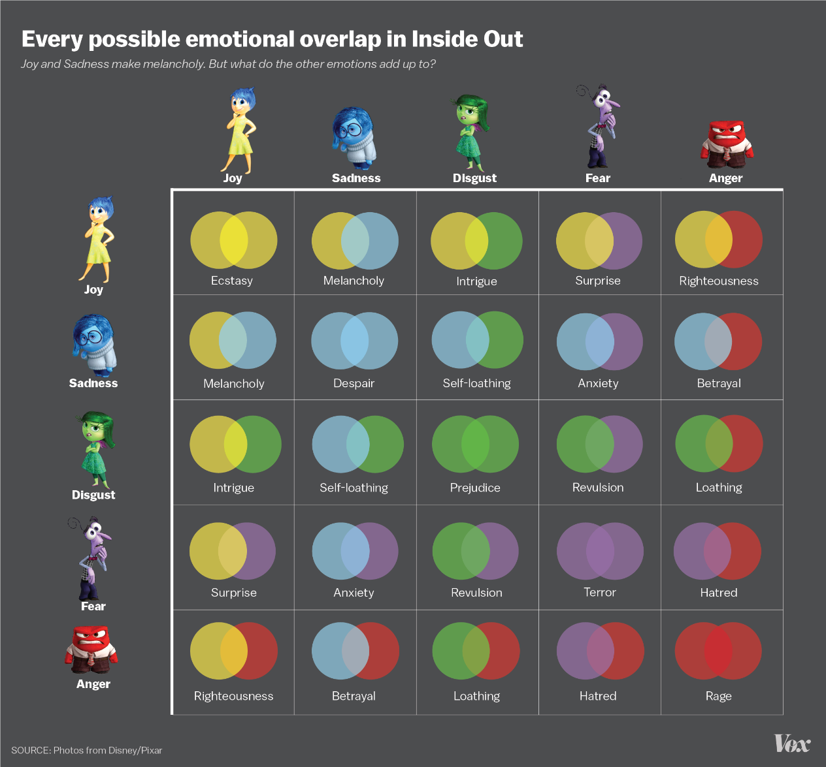
Why do we have sadness?
The movie Inside Out (depicted in the figure above) also shows brilliantly the true purpose of sadness. Sadness functions to bring people together when we need it most. Most humans also have a universal response to sadness – when we see another person is sad, we are naturally drawn to get close to them and provide comfort. Sadness is most commonly a reaction to some sort of loss. Humans tend to get sad when we lose something that was valuable to us. So, the proper response to sadness, then, is to treasure the valuable things you still have, and there is nothing more valuable to humans than connecting with another human.
As I said above, when we see someone is sad, we are naturally drawn to get close to them and provide comfort. But, it’s important to remember too that, like also mentioned above, emotions are a language that does not require any words. So, it doesn’t matter what you say to someone when they are sad. Although kind words of support can go a long way, it’s not what you say that matters, it’s the connection that matters.
Unfortunately, other feelings can sometimes get in the way of sadness doing its intended job. For example, we might be angry too. Anger serves a different purpose than sadness. The purpose of anger is to force us to do things we normally wouldn’t do to fix a problem around us. Anger pushes us out of our comfort zone and triggers us to fight a problem. So, sometimes anger can mix with sadness. If we let the anger get too strong, we might ignore the sadness. Thus, we might get mad at something our best friend did. Rather than allow ourselves to be sad, which is more likely to bring your friend closer to you again, we might let our anger tell us to push the friend away to fix the problem. Sometimes, this might be the right response (maybe this person really was a bad friend), but more often than not, it is only half of the picture. So, we might let anger do its job, but we haven’t let sadness do its job.
“When we don’t let sadness do its job, it can linger.”
When we don’t let sadness do its job, it can linger. This only causes us to feel sadder. The sadness will continue until we allow it to do what it needs to do. In the example above, that might mean forgiving your friend and reconnecting with them. So, when you feel sad, remember that sadness serves two main purposes: 1) to mourn a loss of something valuable, and 2) to encourage use to treasure what we already have that is valuable. Also remember that, to humans, there is nothing more valuable than human connection. So next time you’re sad, one of the best things you can do for yourself is to find real connection with another human. Similarly, if you see someone else is sad, connect with them. Be with them. Don’t worry about saying the “right” thing. Instead, focus on just being near. If you feel like you need to say something, remind the person you care about them and that you’re there with them in their sadness.

Why do we have fear?
Pure fear is designed for self-preservation. Fear keeps us safe and alive. If humans weren’t afraid of anything, we would do all kinds of risky behaviors without appreciating how they could hurt us. So, fear alerts us to things that can hurt us. Fear can also combine with other emotions to modify them a bit. For example, it is possible to be “good-nervous,” which combines joy and fear. This emotion is commonly experienced when we’re trying something or meeting someone new. There is a sense of fear about the unknown, but excitement about possible positive outcomes. We can also exhibit fear and disgust. People commonly experience this emotion in response to bugs. Most bugs are actually quite harmless, but many people find them disgusting. When combined with fear, this disgust can lead us to avoid bugs, even if, in reality, they cannot seriously harm us.
Fear is similar to anger in that it forces us to respond to our environment, perhaps in ways we wouldn’t normally do. Fear helps us notice when something is wrong and then to act in a way to prevent that thing from causing us harm. So, the best way we can respond to fear is to allow it to serve it’s purpose, without overwhelming us. Fear can sometimes grow so strong that it paralyzes us. Like a possum playing dead, this instinct is meant to make threatening things leave us alone; but while that may work with some predators (if you’re ever being actively attacked by a bear, the best defense is supposedly to play dead until the bear leaves you alone), it does not work for most other fears. The instinct to “freeze” or “avoid,” when it doesn’t work, only causes the fear to linger and often grow stronger.
If we can’t get rid of the thing that is causing us fear (which is true of almost all things that scare us), then the best thing we can do is learn to live with that thing, without letting it scare the crap out of us. That’s easier said than done, but it’s possible to learn to appreciate anxiety by noticing it, giving it a little “thanks,” and then reassuring that you can handle it. I often tell my clients to say, “I hear you (anxiety). Thanks for letting me know (about this thing to be afraid of)! I’ll take it from here!” By confidently telling anxiety you’ve “got it,” anxiety does feel as strong of a need to keep reminding you. Once anxiety realizes it doesn’t need to alert you all the time, it will leave you alone!

Why do we have disgust?
Like fear, disgust is meant for self-preservation. Imagine being among the first humans wandering the wilderness. Hunger sets in, and you start to look around wandering what you can eat and what you can’t. You find a couple of options, a colorful, firm, perfectly ripe peach, or a brown, soft, rotten peach. Between the two of them, one causes this odd emotion of suspicion, while the other does not. This is disgust. It’s that instinct of “This is suspicious, I better try this other one instead.” Importantly, disgust is all relative. We only know what is disgusting when comparing it to something less gross. Disgust applies to more than just foods too. For example, if you’re looking for shelter in that same wilderness, and you have a choice between a muddy swamp or a dry, shady forest, you’ll most likely choose the forest. It smells better and feels less gross on your skin. But, if you’re choosing between a muddy swamp or cave absolutely covered in animal feces, you might choose the swamp. These instincts evolved in our ancestors to protect our species from things that could make us sick; and the instincts still pervade in modern society.
Because of these above functions of disgust, disgust can sometimes be triggered by something unfamiliar, but otherwise harmless. When we aren’t used to something, we may feel a little bit cautious about it, and this caution/suspicion triggers feelings that mimic disgust. Disgust can also often overlap with fear, because both emotions are designed for self-preservation. As a result, disgust can be confused with fear, and vice-versa. It is common in many forms of anxiety, for example, for people to develop fear of germs or illness. Most of us by now have had the experience of searching WebMD for our symptoms, only to find pretty much every symptom in the world can be a sign of cancer! Furthermore, if we search hard enough, we can also find “evidence” on the internet that pretty much anything can cause cancer. It’s easy to be frightened by such information, but these fears exist because of our human instinct of disgust and its role in helping us avoid illness. The problem is that instincts are not always rational, and so while its far more likely that our symptoms are not due to cancer, it can be hard to fight that irrational instinct that says, “Avoid this unfamiliar thing.”
This same principal applies to many other unfamiliar things – not just disease. Many humans find themselves disgusted by the idea of homosexuality, racial minorities, children, immigrants, and so on. We often don’t recognize that part of our emotional reactions to a group of people we may not like involves disgust, but it does. The disgust then drives us toward an irrational fear of these groups of people. For some people, disgust can drive them to act aggressively towards these people as a means to “cleanse” their environment. We’ve seen this happen all too often, in both subtle and extremely atrocious ways, in our human history. Through this lens, we can see that disgust has a very dark side, and every single one of us is susceptible to that dark influence.
The best way to fight the darkness of disgust is to notice it when it happens and then consciously challenge the irrational pieces of it. One great way to do this is to seek education, but education is only half the picture. All the facts in the world mean nothing if you don’t also along the way learn to think about them deeply with an open mind and allow them to change your previous perceptions of the world.

Why do we have anger?
I referenced it already above (when discussing sadness), but anger mainly serves to push us out of our comfort zone to change something in our environment that we don’t like. Anger exists so that we humans are left with an option other than tolerance. With anger, we don’t have to just tolerate something bothering us, but we can do something about it. Many times, anger even gives us the courage to act in ways we normally would not so that we can change our environment. So, anger can be quite constructive when used properly. Anger pushes us to solve problems.
But like disgust, anger has a dark side too. Anger becomes dark when it causes us to lose control of our behaviors. Controlled and well-placed, anger does a lot of good, but unrestrained and misplaced, anger can be destructive. Anger is especially dangerous when we find ourselves unable to demonstrate our anger toward the thing that is bothering us. For example, our boss, parent, or teacher may do something annoying that we really hate. Ideally, we’d confront that person and get them to change that behavior, but we often don’t, because of a power differential. We decide it’s too risky to challenge someone who has more power than us, so, instead, we may displace our anger on someone less powerful – our children, our friends, our pets, a random stranger. And this displacement of anger happens all the time.
There are some pretty big problems in the world that many of us feel powerless to change – poverty, hatred, violence, war, hunger. Most of us, if we allow ourselves to focus too often on these enormous problems, would feel angry all the time. So, to protect ourselves from being overpowered by constant anger, we overlook these big problems. What we often forget is that we are not alone in the world, and that by dispersing the anger among many, we can not only support each other emotionally but we can also act as a team to address larger, more significant world problems. In our forgetfulness, then, anger tends to leave us feeling lonely, like this problem only matters to us. When we feel alone AND powerless, we tend to displace our anger onto safer targets. The safer targets may mean small changes in your own life that address the problem on a small scale. For example, you may volunteer at a soup kitchen to address hunger, or you may become a psychologist or therapist and work to teach others about ways to experience more life satisfaction. Safer targets may also mean releasing your anger towards innocent bystanders. Sometimes, this can be done in healthy ways (e.g. venting to your spouse or therapist); other times, displacement can be unhealthy (e.g. yelling at your child because you’re stressed about work). Freud actually had different words for these defense mechanisms. Translated from German to English, Displacement is actually the formal term used for the unhealthy mechanism of taking your anger out on someone or something else. Sublimation, on the other hand, is healthy – it is the conversion of negative energy into something positive and useful. Freud liked physics terms, and so he used sublimation (which in physics refers to the transfer of a substance directly from solid to gas, bypassing the liquid form) to capture the idea of anger (or any other negative emotion) bypassing the “middle phase” of causing us problems and going straight to the end goal, which is to solve the problem in a healthy, useful way.
So, the ultimate goal and healthy response to anger is to allow sublimation to take place, through what we do as individuals and/or through what we do together as a collective species!
Why do we have joy?
For the most part, joy is pretty self-explanatory. Joy exists as an emotional (internal) reward designed to reinforce behaviors that are good for us and conducive to our survival. From an evolutionary standpoint, we humans benefit greatly from social connections (the larger our group, the more we can disperse work and thrive as a society). So friendships and family bring us quite a bit of joy. We also feel joy from exhilarating or thrilling experiences. One argument for this type of joy suggests it comes from the “hunting instinct.” This is also why aggression feels good for some of us. Aggression was once necessary for us to feed ourselves and our friends and families, and so we needed some way to reward aggression, internally. Joy fulfills that role nicely. The same argument is also why intense exercise feels good to us – even though it’s a lot of work, exercise fulfills that hunting instinct we all have in our biology. Nurturance also brings joy. Taking care of others is also important to survival, and that’s why it feels good to do it. As a last example, satiety (having “enough” of something) also feels great, because having “enough” meant that your survival needs were met for the time being.
Now, all of the above is not to say that everything that brings us joy is necessary for survival. I like TV and videogames, but I don’t need them to survive. Instead, what I am saying is only that maximizing behaviors that assist with survival is the original purpose of joy. So, the reason I enjoy videogames is that they fulfill a lot of those instincts that I no longer fulfill on a daily basis (i.e. hunting) because I don’t need to.
So, it’s in developing insights about the original purpose of joy and what you do in your everyday life to fulfill all the parts of joy that really matters. Some of us, for example, may engage in joyful activities that aren’t very healthy for us. We may overeat, drink too much alcohol, use drugs, work hard to earn money at the expense of time with our family, and so on. Occasionally, then, you may find that you need to find better balance in your joy. Sure, eating feels good, but if you’re eating so much that you’re causing obesity, which in turn increases risk for other health problems, then you may decide you want to change that habit toward something healthier. Joy is an extremely powerful reward though, and so it’s hard to change a joy-giving habit without also replacing that habit with something else that approximates that same relative level of joy. Many people fail diets because they aren’t enjoyable. People that succeed, though, develop other rewarding lifestyle habits that facilitate consistency with their diet. Similarly, alcoholics are more successful if they find ways to address the rewards that alcohol brought to them in the first place.
Thus, when you think about your own joy, think about if you have an “excesses” of joy that may be causing you problems in other areas of your life. If you do, try getting help in finding ways to replace those excesses with healthier balances of joy-giving activities.

